DSC650 Final Project: End-to-End Big Data Pipeline for Motorcycle Value Classification

Ayden Trusty
Bellevue University
DSC650: Big Data
Professor Nasheb Ismaily
May 31, 2026

Introduction
The goal of this project was to build a complete big data pipeline using Apache NiFi, HDFS, Hive, Spark MLlib, and HBase. A motorcycle sales dataset was ingested from GitHub, loaded into Hadoop, processed with Spark machine learning, and the resulting evaluation metrics were stored in HBase.

Dataset
Dataset GitHub Repository: https://github.com/TrustyA/DSC650-Big-Data.git
Original: https://www.kaggle.com/datasets/nehalbirla/motorcycle-dataset
The dataset contains motorcycle sales records including name, selling price, year, seller type, owner history, kilometers driven, and ex-showroom price. The project objective was to classify motorcycles into high-value and standard-value categories using Spark MLlib.

Pipeline Overview
GitHub → NiFi → HDFS → Hive → Spark MLlib → HBase. NiFi downloaded the dataset from GitHub and wrote it to HDFS. Hive provided structured storage and querying. Spark MLlib trained a Random Forest classification model, and HBase stored the resulting evaluation metrics.

Issues Encountered
The largest challenge involved a Hive schema mismatch after accidentally working with a different motorcycle dataset. The Hive table had to be recreated with the correct schema. Another issue occurred because Hive LOAD DATA moves files from their original HDFS location. After recreating the table, the dataset had to be reloaded into HDFS before it could be loaded into Hive again. Additional troubleshooting involved distinguishing between local Linux paths and HDFS paths.

Screenshots

Screenshot 1
NiFi flow design and processors used to download, rename, and store the dataset in HDFS.
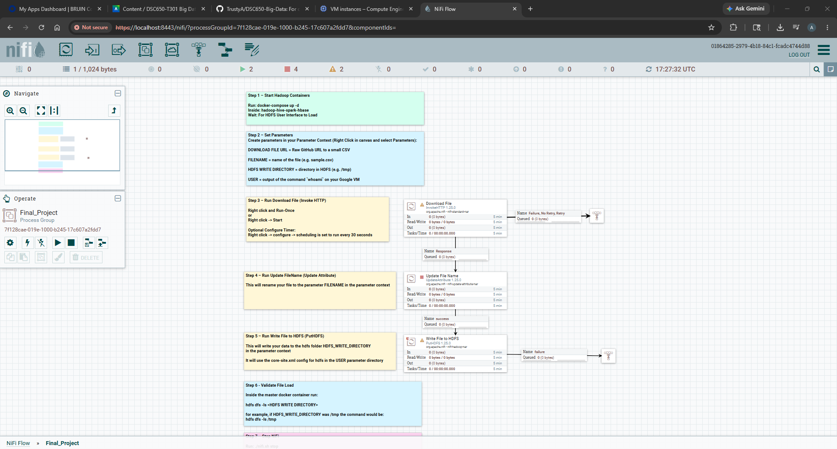

Screenshot 2
NiFi content verification showing the downloaded motorcycle dataset and confirming successful ingestion.
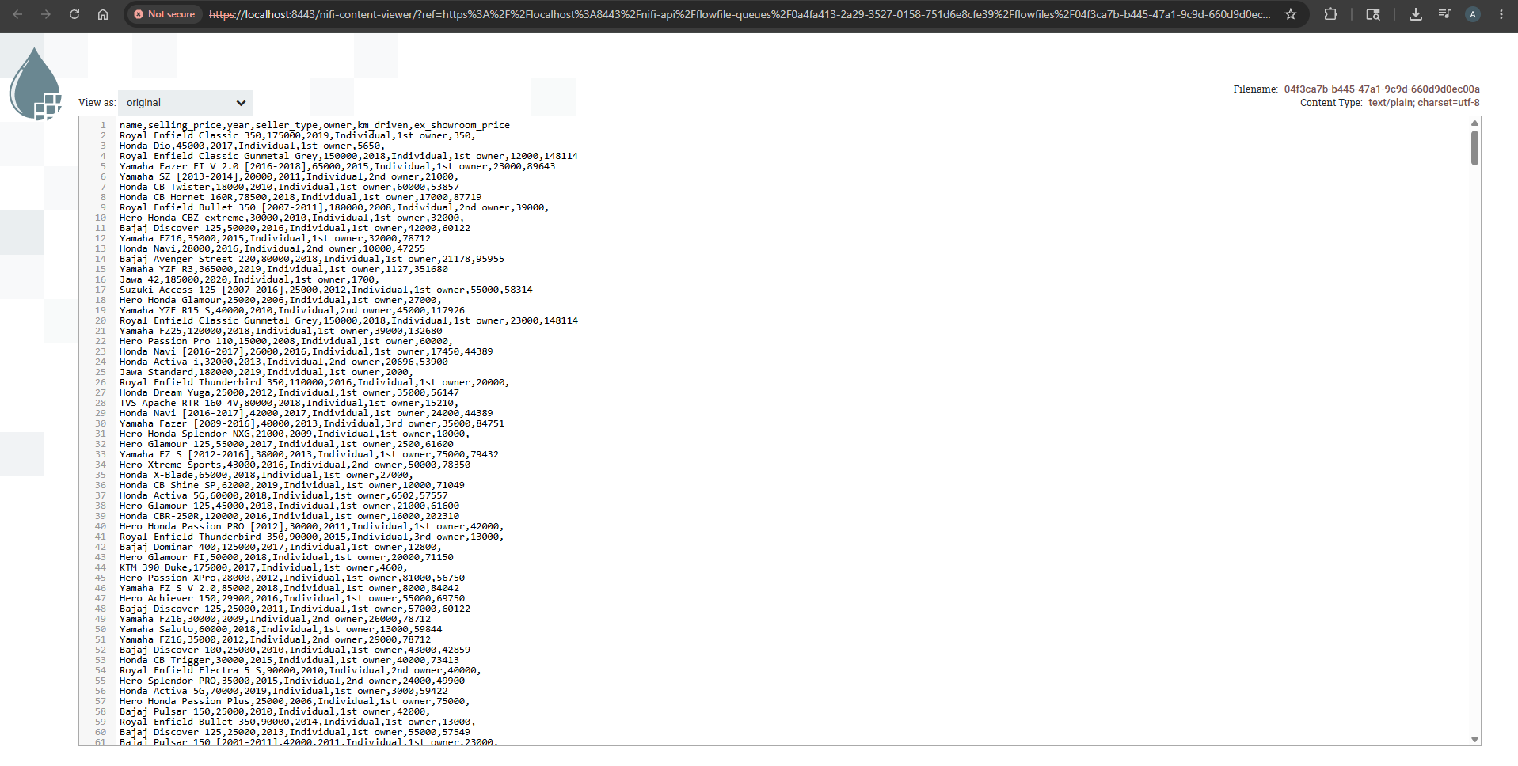

Screenshot 3
HDFS validation showing bike_details.csv successfully written to HDFS.
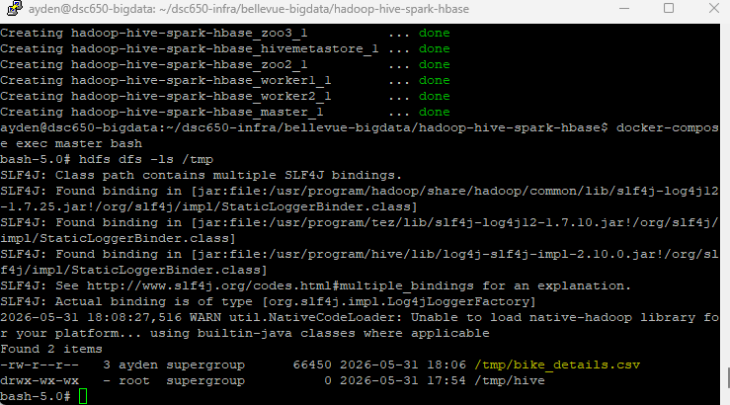

Screenshot 4
Hive LOAD DATA execution confirming the dataset was successfully loaded into the motorcycles table.
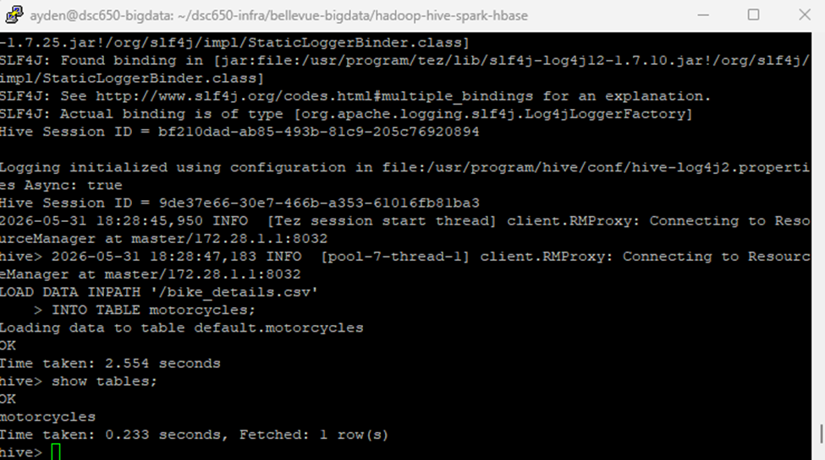

Screenshot 5
Hive query output displaying records loaded into the table and validating the schema.
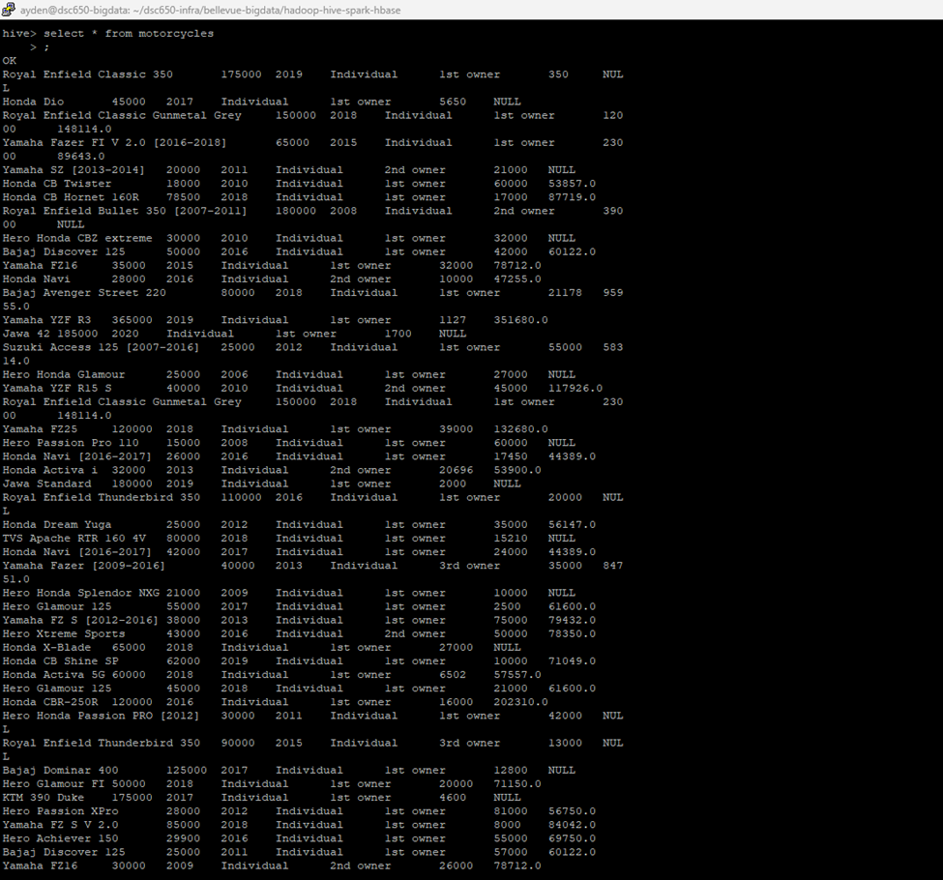

Screenshot 11
Hive aggregation query confirming data population and schema correctness.
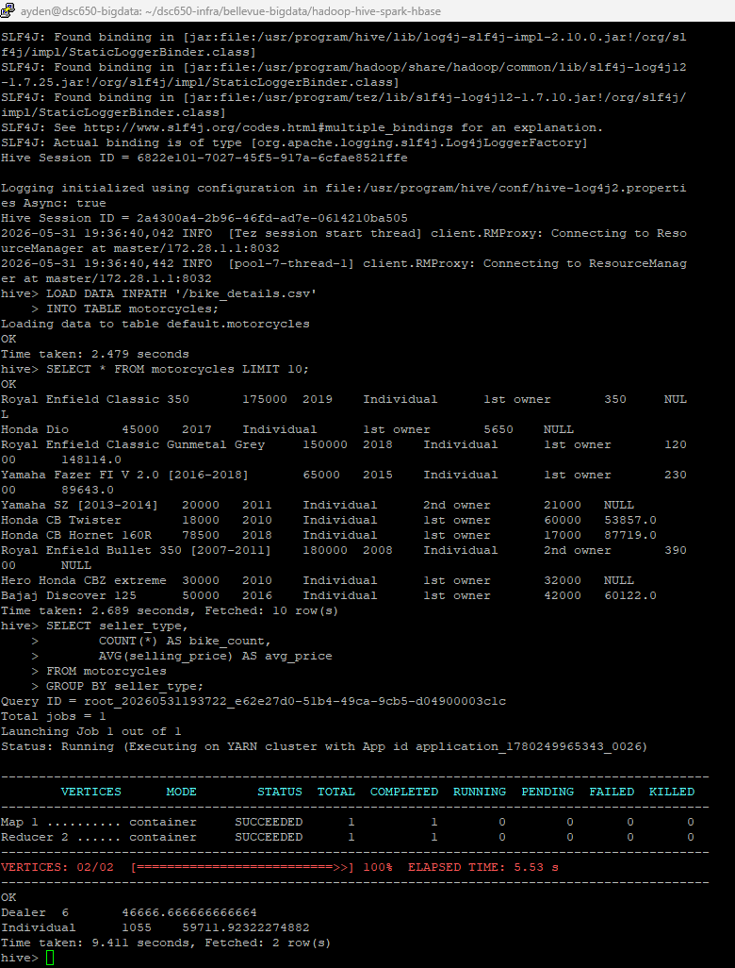

Screenshot 6 (group)
Worker node(s) package installation showing successful installation of numpy and happybase.
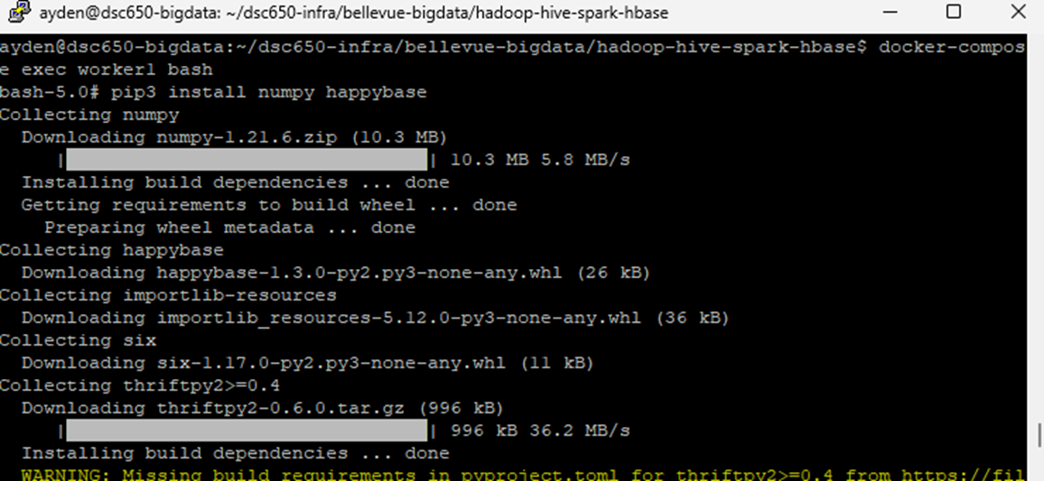
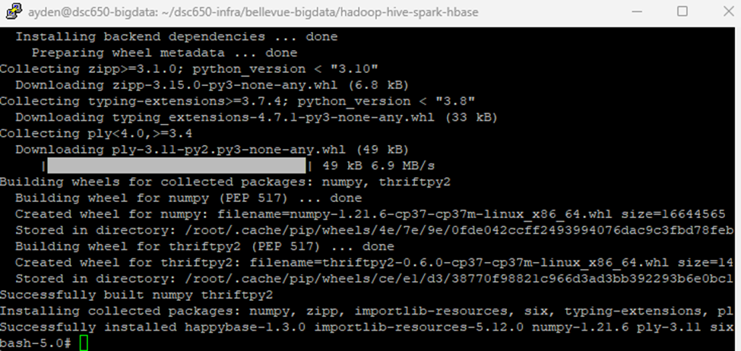
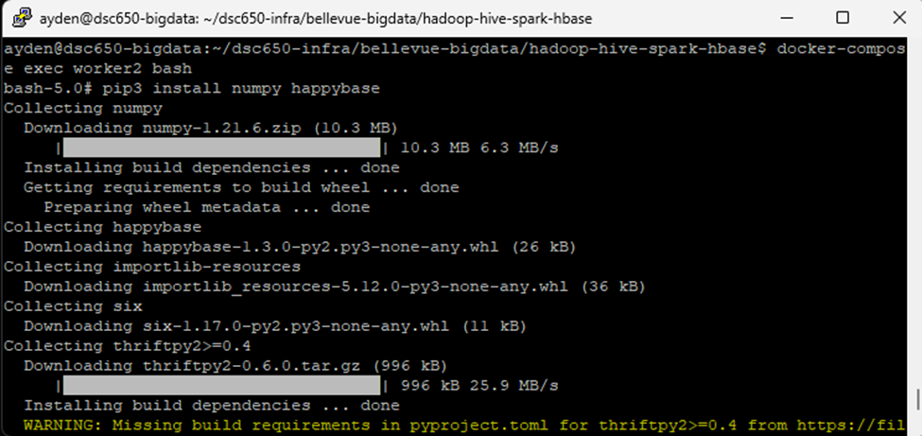
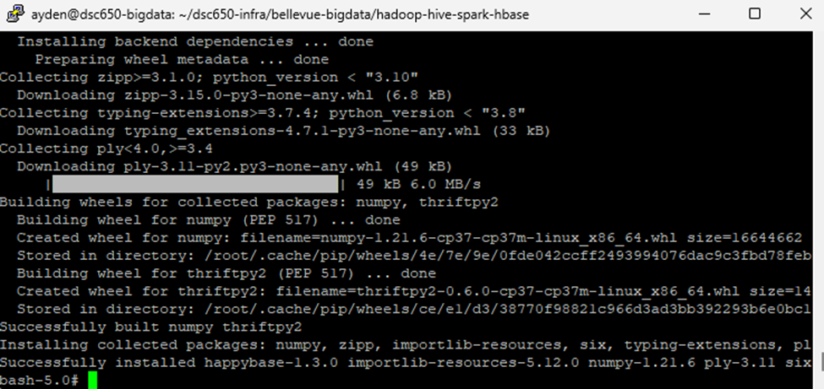

Screenshot 7
Additional environment setup showing package installation on worker and master nodes.
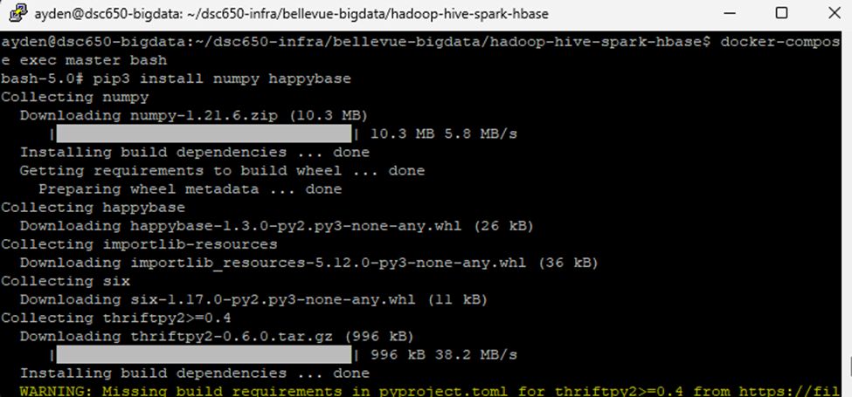

Screenshot 8
HBase table creation showing motorcycle_metrics and an empty scan before Spark writes data.
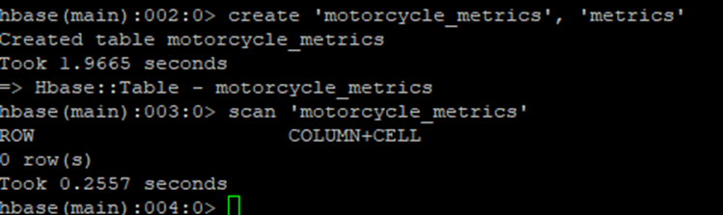

Screenshot 9
Spark MLlib execution output showing successful model training and processing through YARN.
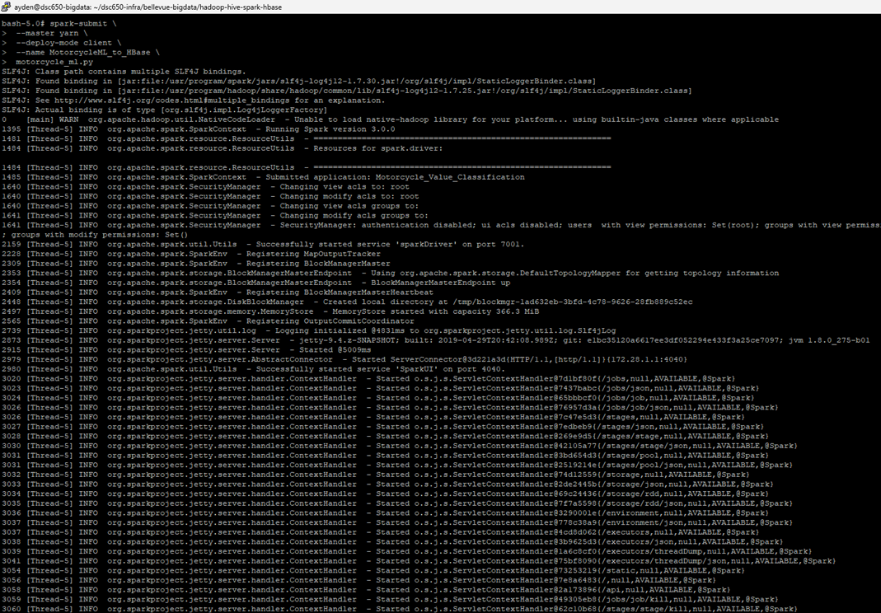
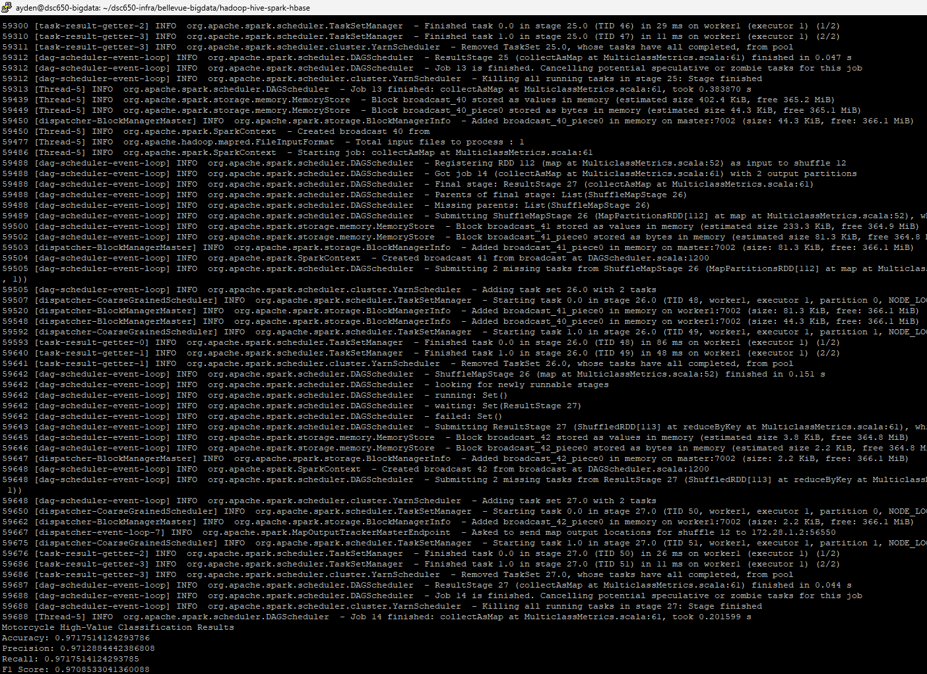

Screenshot 10
HBase verification showing metrics written by Spark, validating end-to-end pipeline execution.
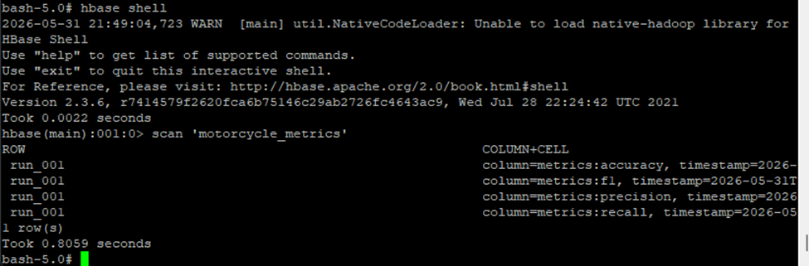

Hive Schema Design
The Hive schema was designed to match the motorcycle sales dataset exactly. Numeric fields such as selling_price, year, km_driven, and ex_showroom_price were stored using numeric types to support analytics and machine learning. Categorical fields such as seller_type and owner were later encoded using Spark StringIndexer.

HBase Design
The HBase table motorcycle_metrics uses a single column family named metrics. A row key of run_001 was used to store model evaluation metrics including accuracy, precision, recall, and F1 score. This design keeps all metrics for a single model execution together in one row.

Machine Learning Approach
A RandomForestClassifier was selected because the problem is a classification task. Motorcycles with a selling price greater than or equal to 100,000 were labeled as high-value motorcycles. Features included year, kilometers driven, ex-showroom price, seller type, and ownership history. The final model achieved approximately 97% accuracy, precision, recall, and F1 score.

Conclusion
This project successfully demonstrated an end-to-end big data workflow using NiFi, HDFS, Hive, Spark MLlib, and HBase. The pipeline successfully ingested data, performed machine learning analysis, and stored evaluation metrics in HBase. The final results confirmed successful integration across all required technologies.

Appendix A - Hive CREATE TABLE Statement
CREATE TABLE motorcycles(
name STRING,
selling_price INT,
year INT,
seller_type STRING,
owner STRING,
km_driven INT,
ex_showroom_price DOUBLE
)
ROW FORMAT DELIMITED
FIELDS TERMINATED BY ','
STORED AS TEXTFILE
tblproperties("skip.header.line.count"="1");

Appendix B - HBase Commands
create 'motorcycle_metrics', 'metrics'
scan 'motorcycle_metrics'

Appendix C - PySpark Code
from pyspark.sql import SparkSession
from pyspark.sql.functions import when, col
from pyspark.ml.feature import VectorAssembler, StringIndexer
from pyspark.ml.classification import RandomForestClassifier
from pyspark.ml.evaluation import MulticlassClassificationEvaluator
import happybase
# Create Spark session with Hive support
spark = (
SparkSession.builder
.appName("Motorcycle_Value_Classification")
.enableHiveSupport()
.getOrCreate()
)
# Load data from Hive table
df = spark.sql("""
SELECT
name,
selling_price,
year,
seller_type,
owner,
km_driven,
ex_showroom_price
FROM motorcycles
""")
# Drop rows with missing important values
df = df.na.drop()
# Create binary label:
# 1 = high value motorcycle
# 0 = standard value motorcycle
df = df.withColumn(
"high_value",
when(col("selling_price") >= 100000, 1).otherwise(0)
)
# Convert categorical columns into numeric indexes
seller_indexer = StringIndexer(
inputCol="seller_type",
outputCol="seller_type_index",
handleInvalid="keep"
)
owner_indexer = StringIndexer(
inputCol="owner",
outputCol="owner_index",
handleInvalid="keep"
)
df = seller_indexer.fit(df).transform(df)
df = owner_indexer.fit(df).transform(df)
# Assemble model features
assembler = VectorAssembler(
inputCols=[
"year",
"km_driven",
"ex_showroom_price",
"seller_type_index",
"owner_index"
],
outputCol="features",
handleInvalid="skip"
)
model_df = assembler.transform(df).select("features", "high_value")
# Split training and testing data
train_data, test_data = model_df.randomSplit([0.7, 0.3], seed=42)
# Train Random Forest classifier
rf = RandomForestClassifier(
labelCol="high_value",
featuresCol="features",
numTrees=50,
seed=42
)
rf_model = rf.fit(train_data)
# Make predictions
predictions = rf_model.transform(test_data)
# Evaluate model
accuracy_evaluator = MulticlassClassificationEvaluator(
labelCol="high_value",
predictionCol="prediction",
metricName="accuracy"
)
precision_evaluator = MulticlassClassificationEvaluator(
labelCol="high_value",
predictionCol="prediction",
metricName="weightedPrecision"
)
recall_evaluator = MulticlassClassificationEvaluator(
labelCol="high_value",
predictionCol="prediction",
metricName="weightedRecall"
)
f1_evaluator = MulticlassClassificationEvaluator(
labelCol="high_value",
predictionCol="prediction",
metricName="f1"
)
accuracy = accuracy_evaluator.evaluate(predictions)
precision = precision_evaluator.evaluate(predictions)
recall = recall_evaluator.evaluate(predictions)
f1 = f1_evaluator.evaluate(predictions)
print("Motorcycle High-Value Classification Results")
print(f"Accuracy: {accuracy}")
print(f"Precision: {precision}")
print(f"Recall: {recall}")
print(f"F1 Score: {f1}")
# Write metrics to HBase
data = [
("run_001", "metrics:accuracy", str(accuracy)),
("run_001", "metrics:precision", str(precision)),
("run_001", "metrics:recall", str(recall)),
("run_001", "metrics:f1", str(f1)),
]
def write_to_hbase_partition(partition):
connection = happybase.Connection("master")
connection.open()
table = connection.table("motorcycle_metrics")
for row in partition:
row_key, column, value = row
table.put(row_key, {column: value})
connection.close()
rdd = spark.sparkContext.parallelize(data)
rdd.foreachPartition(write_to_hbase_partition)
spark.stop()

